CO4 – AT1: Data Interpretation
Student Name:K.M.Pranay Reg. No.:192321055
Section / Batch: 2023 Date:20/08/2026

1. Real-Time Detection System Understanding of the Case
The surveillance system must detect objects or people in real time. The two most important requirements are low latency and acceptable detection accuracy. A method with very high accuracy but slow processing may not be suitable when immediate detection is required.
Comparison
Method | Accuracy | Speed | Suitability
Viola-Jones | 78% | Fast | Excellent latency, moderate accuracy
YOLO | 92% | Moderate | Good balance
Deep Learning | 95% | Slow | Highest accuracy but high latency
Application of Concepts
Viola-Jones is computationally lightweight and therefore provides fast detection. However, its 78% accuracy can result in more false detections or missed objects.
YOLO provides 92% accuracy with moderate speed, making it considerably more accurate while still being capable of real-time operation on suitable hardware.
The deep-learning approach provides the highest accuracy at 95%, but its slower processing makes it less appropriate when strict latency requirements exist.
Analysis
For a surveillance system, a detection delay can be more problematic than a small reduction in accuracy. For example, in security monitoring, delayed detection of a person entering a restricted area can reduce the usefulness of the system.
Therefore:
- Viola-Jones: Best latency but lower accuracy.
- YOLO: Strong balance between accuracy and speed.
- Deep Learning: Best accuracy but poor latency.
Solution Design
YOLO should be selected when the system requires strict latency constraints while maintaining high and acceptable accuracy.
It provides a significant accuracy improvement over Viola-Jones while avoiding the excessive latency associated with the slower deep-learning method.
Deployment Conditions
YOLO is particularly suitable when:
- Real-time detection is required.
- GPU or edge-AI hardware is available.
- Accuracy above approximately 90% is desirable.
- Moderate processing latency is acceptable.
- The system must continuously process surveillance video.
Result
The result graph below demonstrates the accuracy-speed trade-off.
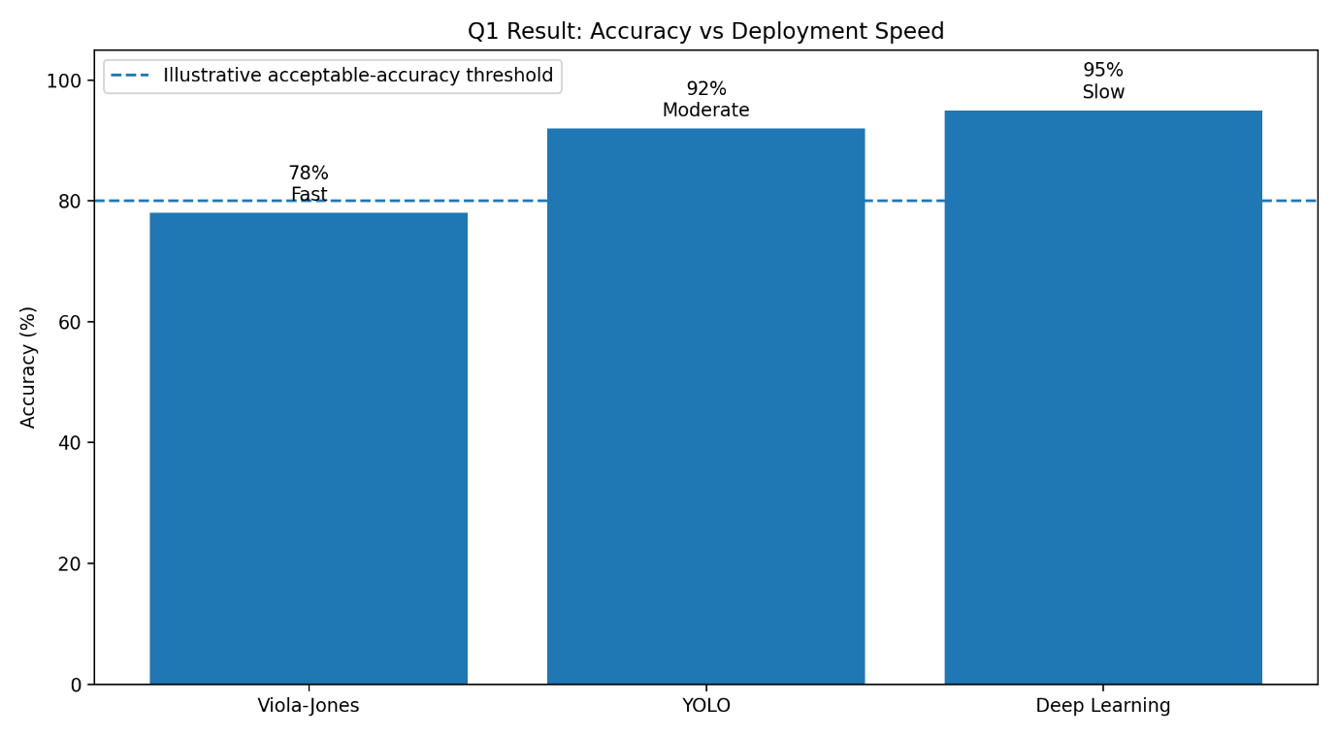
Conclusion
YOLO is the best overall choice for the given surveillance application because it provides 92% accuracy with moderate speed, giving a better practical balance between detection quality and real-time responsiveness.

2. Robust Object Detection
Understanding of the Case
A robust object-detection system must maintain its performance when environmental conditions change. The three important conditions are:
- Normal conditions
- Occluded objects
- Low-light environments
The given data are:
Method | Normal | Occlusion | Low Light
Viola-Jones | 80% | 60% | 55%
YOLO | 90% | 75% | 70%
Third method* | 95% | 85% | 80%
*The method name is missing from the supplied question.
Application of Concepts
Viola-Jones performs reasonably under normal conditions but its performance decreases significantly when objects are partially hidden or illumination is poor.
YOLO demonstrates better robustness:
- 90% under normal conditions
- 75% under occlusion
- 70% under low light
The third method has the highest values across all three conditions based on the supplied data.
Analysis
The average performance can be calculated as:
Viola-Jones:
[
\frac{80+60+55}{3}=65%
]
YOLO:
[
\frac{90+75+70}{3}=78.33%
]
Third method:
[
\frac{95+85+80}{3}=86.67%
]
Therefore, based strictly on the provided numerical data, the third method has the highest
overall robustness.

Trade-Offs
Viola-Jones
- Advantage: Simple and computationally efficient.
- Disadvantage: Significant performance degradation under difficult conditions.
YOLO
- Advantage: Strong balance between robustness and practical deployment.
- Disadvantage: Requires more computational resources.
Third method
- Advantage: Highest performance in every listed condition.
- Disadvantage: Its actual computational cost and method characteristics cannot be determined because its name is missing.
Solution Design
Based strictly on the supplied numerical results, the third method should be selected for maximum robustness.
However, if deployment resources and real-time requirements are important, YOLO may be preferred as a practical alternative, because it provides strong performance while generally offering a favorable accuracy-versus-computation trade-off.
Result
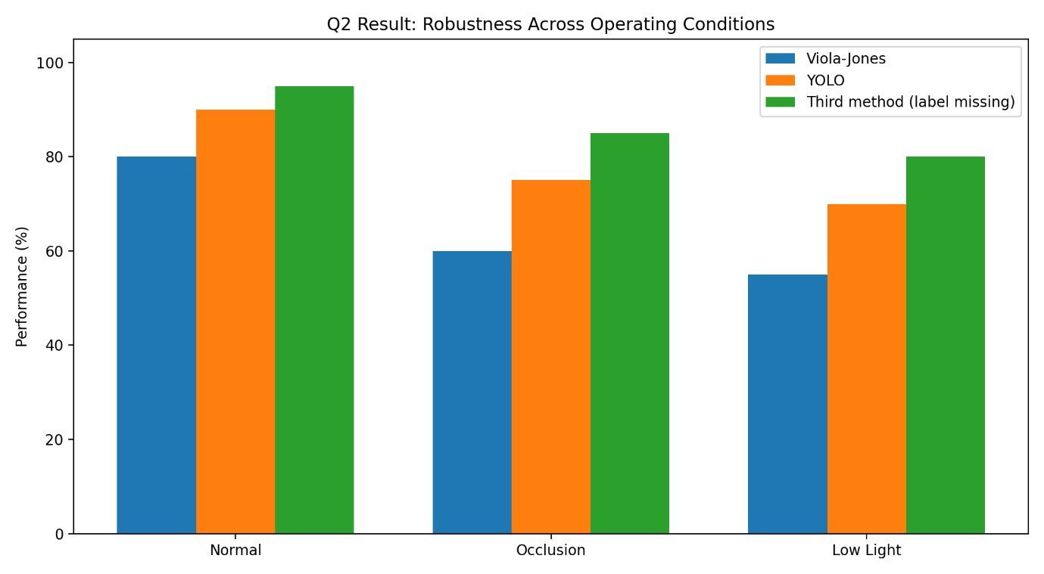

Conclusion
The third method has the best numerical overall performance at 86.67% average accuracy, followed by YOLO at 78.33% and Viola-Jones at 65%. Therefore, the third method is the best choice based solely on the supplied data, while YOLO is a strong practical choice when computational constraints are considered.

3. Optical Flow Analysis
Understanding of the Case
Optical flow is used to estimate the apparent movement of objects between consecutive frames. The two available methods have different characteristics:
- Method A: Stable motion vectors but misses small movements.
- Method B: Detects fine movements but produces noisy vectors.
The decision therefore requires balancing accuracy, stability, noise sensitivity, and application requirements.
Comparison
Criterion | Method A | Method B
Motion-vector stability | High | Moderate/Low
Small-motion detection | Poor | Excellent
Noise sensitivity | Low | High
Reliability | High | Moderate
Fine-motion tracking | Limited | Excellent
Application of Concepts
Method A is suitable when stable and reliable motion estimation is more important than detecting very small movements.
Method B is better at identifying subtle movements but its noisy vectors can result in false motion estimates. Noise filtering or smoothing may therefore be required.
Analysis
For a dynamic scene containing vehicles, people, or large moving objects, stable motion vectors are important because unstable vectors can cause incorrect tracking trajectories.
However, applications such as:
- Hand-motion analysis
- Gesture recognition
- Micro-movement detection
- Fine object tracking
may benefit more from Method B.
Solution Design
For general-purpose motion tracking in dynamic scenes, Method A is the safer choice because stability and reliable tracking are usually more important than detecting extremely small movements.
A suitable improvement would be to combine Method A with a small-motion enhancement or adaptive refinement stage.
Result
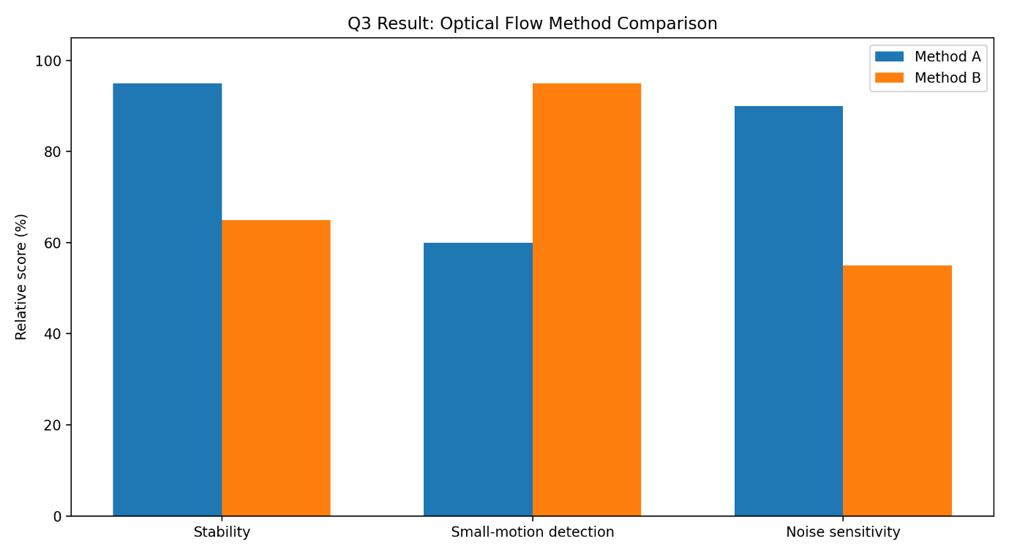
Conclusion
Method A is recommended for general dynamic-scene tracking because it provides stable motion vectors and is less sensitive to noise. Method B should be selected when detecting small movements is the primary requirement and additional noise-reduction processing is acceptable.

4. Model Generalization and Overfitting
Understanding of the Case
The purpose of comparing training and testing accuracy is to determine how well a model generalizes to unseen data.
Given:
Model | Training Accuracy | Testing Accuracy | Generalization Gap
A | 98% | 70% | 28%
B | 90% | 88% | 2%
Application of Concepts
The generalization gap is:
[
\text{Training Accuracy} - \text{Testing Accuracy}
]
For Model A:
[
98-70=28%
]
For Model B:
[
90-88=2%
]
Analysis
Model A achieves an excellent 98% training accuracy but falls to only 70% during testing. This large 28% gap indicates that the model has learned the training data too specifically.
This is a strong indication of overfitting.
Model B has a training accuracy of 90% and testing accuracy of 88%. Its 2% gap indicates that its performance remains consistent on unseen data.
Therefore, Model B has significantly better generalization ability.
Solution Design
Model B should be selected for real-world deployment.
Although Model A has a higher training accuracy, real-world systems operate on previously unseen data. Therefore, testing accuracy and generalization are more important than achieving an extremely high training accuracy.

Result
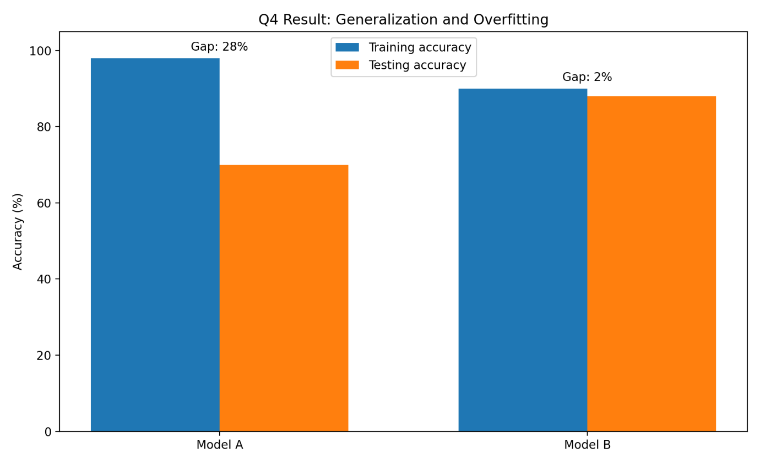
Conclusion
Model B is more reliable for real-world deployment.
Model A has a 28% generalization gap and high overfitting risk, whereas Model B has only a 2% gap, demonstrating strong generalization and better reliability on unseen data.

5. System Performance under Constraints
Understanding of the Case
A real-time application must balance three major factors:
- Accuracy
- Latency
- Cost
The available models are:
Model | Accuracy | Latency | Cost
A | 88% | 50 ms | Low
B | 92% | 80 ms | Moderate
C | 95% | 120 ms | High
Application of Concepts
Latency is particularly important in real-time applications. Lower latency means that the system can respond more quickly.
Model A provides the lowest latency and cost but has the lowest accuracy.
Model C provides the highest accuracy but also has the highest latency and cost.
Model B lies between the two and provides a strong compromise.
Analysis
Model | Accuracy | Latency | Cost | Overall Evaluation
A | 88% | 50 ms | Low | Fast and economical
B | 92% | 80 ms | Moderate | Best balance
C | 95% | 120 ms | High | Highest accuracy but expensive
The accuracy improvement from Model B to Model C is only:
[
95-92=3%
]
However, latency increases by:
[
120-80=40ms
]
and the cost also increases from moderate to high.
Therefore, the additional 3% accuracy may not justify the increased deployment cost and latency for many real-time applications.
Solution Design
Model B is the recommended solution.
It provides:
- 92% accuracy
- 80 ms latency
- Moderate cost
This represents the best balance between performance and practical deployment requirements.
Model A should be selected when extremely low cost and latency are the highest priorities.
Model C should be selected only when maximum accuracy is more important than latency and cost.
Deployment Conditions
Model B is especially suitable for:
- Real-time surveillance
- Smart traffic monitoring
- Industrial monitoring
- Edge-AI applications
- Real-time object detection
Result
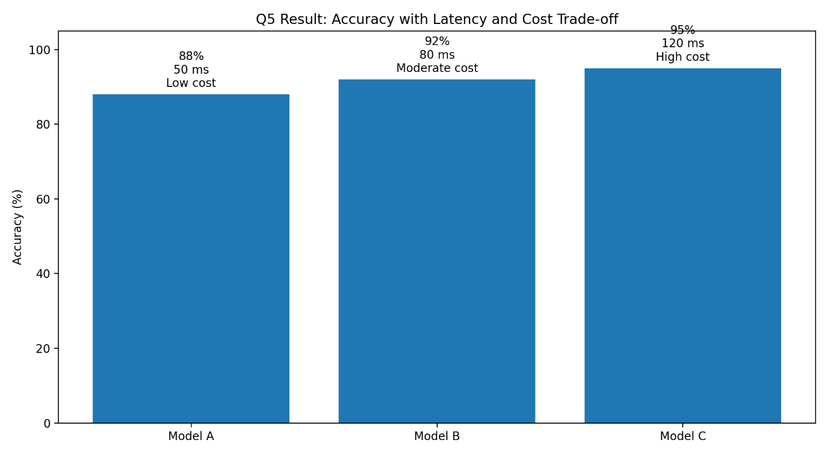
Conclusion
Model B provides the best overall balance between accuracy, latency, and cost. Its 92% accuracy is substantially better than Model A while avoiding the high latency and cost associated with Model C.

